Web Design with Visual Studio 2013

*Last saved: 1 February 2014 , 4:55 PM*

# Edit html files using MS Visual Studio

## Load folder containing html files in MS Visual Studio 2012

Open MS Visual Studio – click on File – Open – Website (Shift + Alt + O) – Navigate to the folder – Highlight it – click on Open.

# Bug: Visual Studio 2013 Missing Design, Source and Split buttons

*Source:* <https://connect.microsoft.com/VisualStudio/feedback/details/796625/visual-studio-2013-missing-design-source-and-split-buttons>

*Additional:* [*http://madskristensen.net/post/open-static-html-files-in-the-visual-studio-2013-designer*](http://madskristensen.net/post/open-static-html-files-in-the-visual-studio-2013-designer)

Fix:

## 1. Open the html file in Visual Studio

1.1. If you want to load in Visual Studio a website or a list of html files located in a single folder then:

Open Visual Studio - File - Open - Web Site – Navigate to the folder where the html file is located – Highlight it – Click on OK

1.2. If you want to load a single html file in Visual Studio then:

Open Visual Studio - File - Open – File (or just press Ctrl + O)

After the html file(s) load in Visual Studio Solution Explorer then:

## 2. Set the HTML (Web Forms) Editor as Default

In Visual Studio Solution Explorer (on the right) - Right-click on the html file - Open With - Highlight "HTML (Web Forms) Editor" - Set as Default – OK

# Change the HTML Designer Default View

1. Make sure that HTML Designer is enabled in Visual Studio

* VS - Tools - Options - HTML Designer - General - Enable HTML Designer (should be marked)

1. Tools – Options – HTML Designer – General - Start pages in – “Split View”
2. Tools – Options – HTML Designer – General - Split views vertically

# Synchronize Designer view and Source view after editing source code

When you make some changes in the html code in order to synchronize the Source View and Designer View follow one of the options below:

1. Click on the message in the top of the Designer view: “Design view is out of sync with Source view. Click here to synchronize views.”
2. Save the changes made to the file (Ctrl + S)

# Open html file in default browser from Visual Studio

1. Double click on the html file in MS Visual Studio Solution Explorer
2. Press **Ctrl + F5** (Debug – Start without Debugging)

The file should open in the default browser.

# Testing Web Pages in browser

## Option 1

1. Click on the down arrow next to **Debug Target** (which is on the Standard toolbar next to the **Start Debugging** button)
2. Select the web browser of your choice

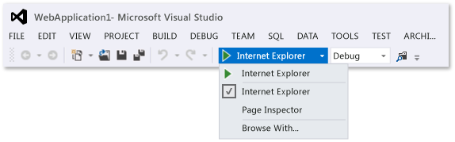

1. Test the webpage in browser
   1. In the **Menu bar** click on **Debug** - **Start without Debugging** (or press CTRL+F5.)

A second option is:

* 1. Click on the Debug Target button (or on the Debug menu click Start Debugging, or press F5)

*For option 3.2 when you switch back to Visual Studio and would like to edit the code make sure you choose Debug – Stop Debugging (Shift + F5)

The web page will open in the specified browser

References:

<http://msdn.microsoft.com/en-us/library/jj153218.aspx>

## Option 2

1. Right click on the html file in the **Solution Explorer** (located in the right section of MS Visual Studio)
2. Click on View in Browser

If you would like to choose another installed browser then:

1. Click on **Browse With**
2. Choose a web browser
3. Click on **Browse** button

The web page will open in the specified browser

References:

<http://msdn.microsoft.com/en-us/library/df5x06h3.aspx>

<http://msdn.microsoft.com/en-us/library/df5x06h3%28v=vs.110%29.aspx>

Conclusion: Option 1 is faster

Review:

1. Click on the down arrow next to **Debug Target** (which is on the Standard toolbar next to the **Start Debugging** button)
2. Select the web browser of your choice
3. Press CTRL+F5 (Debug - Start without Debugging)

Remark: If the html file is already opened in the browser, then you modify it and save it, after that please just *refresh* the page in the browser (e.g. if using Firefox press F5).

# Open webpage in Page Inspector

Right click on the html file in the Solution Explorer – click on **View in Page Inspector** (Ctrl + K, Ctrl + G)

If the Debugging Mode is not enabled in the Web.config file or there is no Web.config file created you will see the message below. In that case please click on **OK**

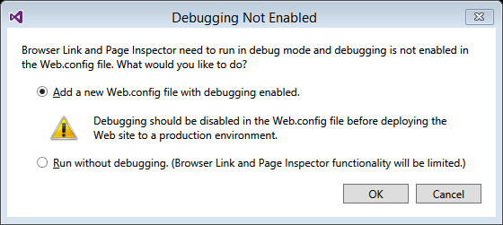

*You can auto-hide the Page Inspector window by clicking on the pin icon in the top right corner of the Page Inspector

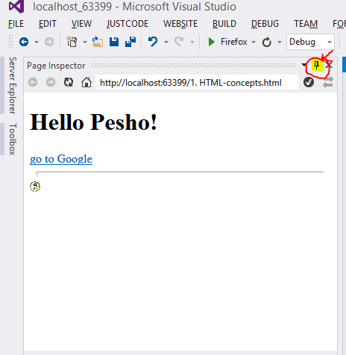

*The Page Inspector window could be maximized by clicking on Page Inspector at the Auto-hide bar (at the most left part of Visual Studio)

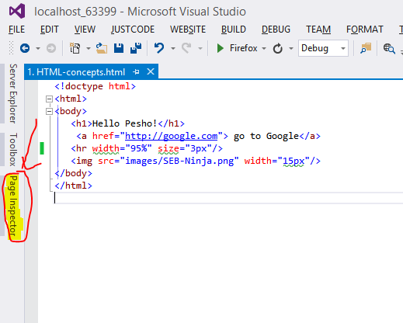

# Remove website from Visual Studio Solution Explorer

File – Close Solution – Save Changes (Yes - No)